Computer Programming Laboratory

Tutor: dr inż. Karolina Nurzyńska
Author: Kacper Raczyński

                - Task topic
Books in the library are described by the author’s name, title and labels. Label assign a label to the book department. Each book can have several labels. List of books stored in the file is as follows:
{ author} ; {title} ; { label} [, { label }]
Example file:
Plato; Feast; philosophy
Shakespeare, Hamlet, tragedy, baroque
Cormen, Algorithms, computer science, handbook
Mickiewicz, Pan Tadeusz, classics, romance, reading
Aquinas, Summa of Theology, Philosophy, Medieval
The task is to save to the file books by labels. Books bearing the same label are sorted by the author’s name, for example:
philosophy: Aquinas, Summa of Theology Plato; Feast
baroque Shakespeare, Hamlet
tragedy Shakespeare, Hamlet ...
The program is run from the command line using the following switches:
-i input file
-o output file

                - Project analysis
Data structures which I used in this program:
-structure which holds name of category.
-sturcture which keeps author name, name of the book, numbers of categories for that author, and pointer this categories
- STRUCTURE which holds other structures and size of them( its like inp file after a treatment)
Most interesting functions:

-bazaKsiazek.ksiazki = (Ksiazka*)malloc(rozmiar*sizeof(Ksiazka));( initialazing base containing all books on given size)

-strncpy(bazaKsiazek.ksiazki[i].autor, bufor, pierwszySrednik);(ascription author)

-strncpy(bazaKsiazek.ksiazki[i].tytul, bufor + pierwszySrednik+1, drugiSrednik - pierwszySrednik - 1);( ascription title)

!isalpha ( searching for alphabet sign)

if (strcmp(baza.ksiazki[i].kategorie[j].nazwa, baza.ksiazki[l].kategorie[k].nazwa) == 0)
fprintf(plik, "\t%s\t%s\n", baza.ksiazki[l].autor, baza.ksiazki[l].tytul); ( printing other authors with the same category)

3.Internal Specification
#define DL_MAX 64
#define BUFOR 2048
(designing 2 pernament to limit the lenght of words in input file and the lenght of input file)
typedef struct _Kategoria
{
char nazwa[DL_MAX];
}Kategoria;( designing the structer for categories from input file)
typedef struct _Ksiazka
{
char autor[DL_MAX];
char tytul[DL_MAX];
int iloscKategorii;
Kategoria* kategorie;
}Ksiazka;( designing the structur conteining autors name title of a book numbers of categories and poiter to this structure categories)
typedef struct _BazaKsiazek
{
int rozmiar;
Ksiazka* ksiazki;
}BazaKsiazek; (structure conteing all information about the book and size of this information books, all)
BazaKsiazek wczytajPlik(char* nazwaPliku)
(function for getting information about a file)
FILE* plik = fopen(nazwaPliku, "r");( opening given input file)
if (plik == NULL)
{
printf("Nie mozna otworzyc pliku do odczytu!");
system("PAUSE");
exit(-1);
}( if input file is empty the program shows the messsage)
BazaKsiazek bazaKsiazek;
bazaKsiazek.ksiazki = (Ksiazka*)malloc(0 * sizeof(Ksiazka));( starting with array of 0 size)

char bufor[BUFOR];
char kategorie[BUFOR];
char dzielnik = ';';
int pierwszySrednik = -1;
int drugiSrednik = -1;
int poprzedniPrzecinek = -1;
int nastepnyPrzecinek; ( some variables which will be helpfull in assigning categories and author/ title)
fscanf(plik, "%s\n", bufor);( reading file and putting it in array)
if (bufor[j] == dzielnik && pierwszySrednik == -1)
pierwszySrednik = j;
if (bufor[j] == dzielnik && pierwszySrednik != -1)
drugiSrednik = j;(searching for the semicolon to determine author and title)
strncpy(bazaKsiazek.ksiazki[i].tytul, bufor + pierwszySrednik+1, drugiSrednik - pierwszySrednik – 1); ( ascription title)
strncpy(bazaKsiazek.ksiazki[i].autor, bufor, pierwszySrednik);( ascription author)
bazaKsiazek.ksiazki[i].autor[pierwszySrednik] = '\0';
bazaKsiazek.ksiazki[i].tytul[drugiSrednik - pierwszySrednik - 1] = '\0';( ending of ascription author and title with sign of string end)
bazaKsiazek.ksiazki[i].iloscKategorii = 0; ( making numers of categories equal 0)
strcpy(kategorie, bufor + drugiSrednik+1);( copying from file to array kategorie)
for (j = 0; j < strlen(kategorie); j++)
{
if (kategorie[j] == ',')
bazaKsiazek.ksiazki[i].iloscKategorii++;
}
( checking what was copied if program finds comma it increase the numbers of categories )
bazaKsiazek.ksiazki[i].kategorie = (Kategoria*)malloc(bazaKsiazek.ksiazki[i].iloscKategorii*sizeof(Kategoria));(initialize array on size of category +1 cause there are 2 comas and 3 categories)
poprzedniPrzecinek++;( setting it to zero to start counting nr of categories)

for (k = poprzedniPrzecinek; k < strlen(kategorie); k++)
{
if (kategorie[k] == ',')
{
nastepnyPrzecinek = k;
break;
}
}
if (k == strlen(kategorie))
nastepnyPrzecinek = k;
strncpy(bazaKsiazek.ksiazki[i].kategorie[j].nazwa, kategorie + poprzedniPrzecinek, nastepnyPrzecinek - poprzedniPrzecinek);
bazaKsiazek.ksiazki[i].kategorie[j].nazwa[nastepnyPrzecinek - poprzedniPrzecinek] = '\0';
poprzedniPrzecinek = nastepnyPrzecinek;
}( finding the place where the come is set, then copy all char which appeared earlier to structure kategorie, creating categories)

i++;(checking another book )

fclose(plik);(closing input file)

void zapiszDane(BazaKsiazek baza, char* plikWyjsciowy)( function writing date in output file)
int i, j, k, l, m;
int rozmiarWypisanych = 0;(values which we will need in future operations)
if (plik == NULL)
{
printf("Nie mozna otworzyc pliku do zapisu!");
system("PAUSE");
return 0;
} ( emergency if output file dont exist )
for (i = 0; i < baza.rozmiar; i++)
{
for (j = 0; j < baza.ksiazki[i].iloscKategorii; j++)
(loops which are necessary to writte a text in output fille)
if (niewypisana == 1)
{
rozmiarWypisanych++;
wypisane = (Kategoria*)realloc(wypisane, rozmiarWypisanych*sizeof(Kategoria));
memcpy(&wypisane[rozmiarWypisanych - 1], &baza.ksiazki[i].kategorie[j], sizeof(Kategoria)); ( making array on current size of category and adding it )
int niewypisana = 1;
for (k = 0; k < rozmiarWypisanych; k++)
if (strcmp(wypisane[k].nazwa, baza.ksiazki[i].kategorie[j].nazwa) == 0)
niewypisana = 0;( checking if the category already have been written)

fprintf(plik, "%s:\n", baza.ksiazki[i].kategorie[j].nazwa);(writting category to file
for (l = i; l < baza.rozmiar; l++)
{
for (k = 0; k < baza.ksiazki[l].iloscKategorii; k++)
{
if (strcmp(baza.ksiazki[i].kategorie[j].nazwa, baza.ksiazki[l].kategorie[k].nazwa) == 0)
fprintf(plik, "\t%s\t%s\n", baza.ksiazki[l].autor, baza.ksiazki[l].tytul);
}( checking all books for certain category, and adding books to this category in file )
}
fprintf(plik, "\n"); ( printing file)

fclose(plik);( closing output)

void usunBaze(BazaKsiazek baza)
{
int i, j, k;
for (i = 0; i < baza.rozmiar; i++)
{
free(baza.ksiazki[i].kategorie);
}
free(baza.ksiazki);
}( function which clears the arrays)

int main(int argc, char *argv[])
{
if (argc != 5)
printf("Nie mozna otworzyc pliku do zapisu!");
else
{
int i;
char inp[100], outp[100];
pobraniePlikuWe = pobraniePlikuWy = 0;( setting flag to find out whats went wrong)
for (i = 1; i <=3; i+=2)
{
if (strcmp(argv[i], "-i") == 0) strcpy(inp, argv[i + 1]);
if (strcmp(argv[i], "-o") == 0) strcpy(outp, argv[i + 1]);
}
}( reading parameters from cmd)
char* nazwaPlikuWe = inp;
char* nazwaPlikuWy = outp; ( making values form parameters)
BazaKsiazek baza = wczytajPlik(nazwaPlikuWe);
zapiszDane(baza, nazwaPlikuWy);
usunBaze(baza);( doing all staff)

if (pobraniePlikuWe == 0)
{
printf("Niepoprawny plik wejsciowy");
return -1;
}

if (pobraniePlikuWy == 0)
{
printf("Niepoprawny plik wyjsciowy");
return -1;
}( printing errors).

- External Specyfication
Program works on already set parameters, which u can change in project properties. How the program works? 1st function take one line from input file search for 2 semicolon, then add the book author and title to the array size of structur Ksiazka times number of lines in input file. After it it counts number of categories for certain book and add it to structure. With this information program is able to devide rest of text to categories and add them to array of structures of size number of categories times size of structure categories. After it combine all together. And going to another line, till the end of file It returns all big structure where are all information from input file.
2nd program is checking category form first saved book it checks if category was already written in new array called wypisane if the category showed 1st time it puts it in this array and puts it in output file with book information contained with this category, then check all books for this category, if other book have the same category its also puts this book in output. It works this way till it finds end of all book saved in base. Then it just free all allocated memory .

- Testing
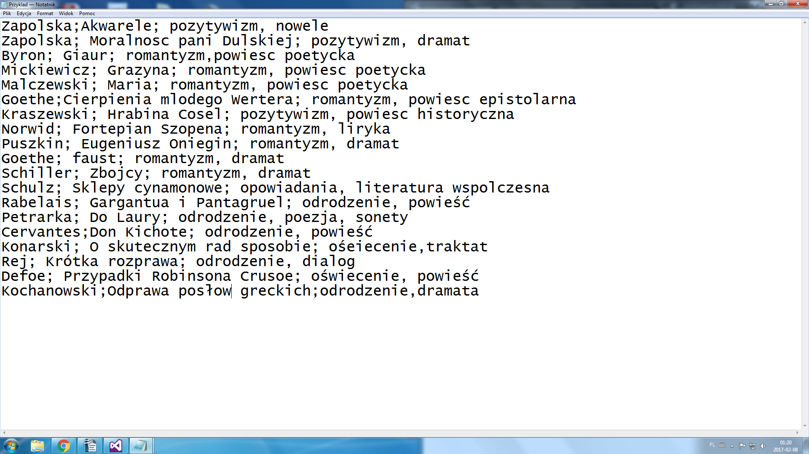
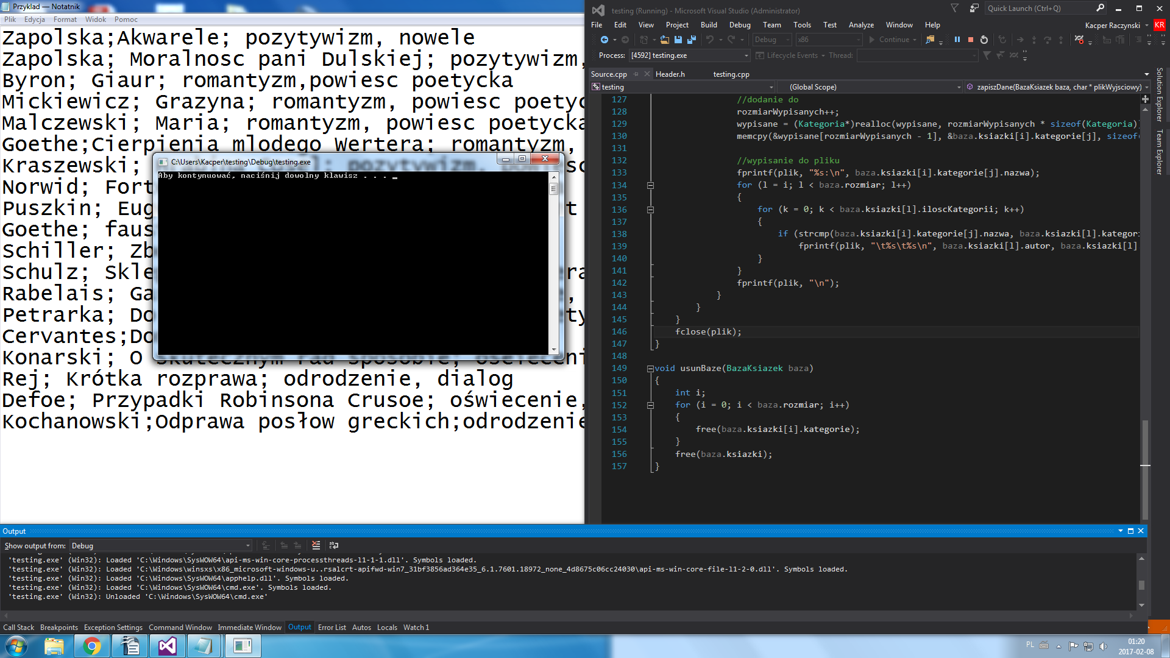
Working :D

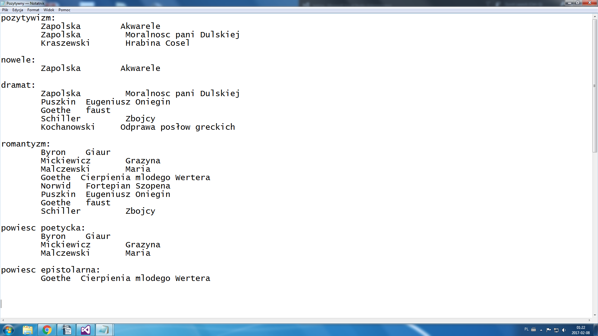
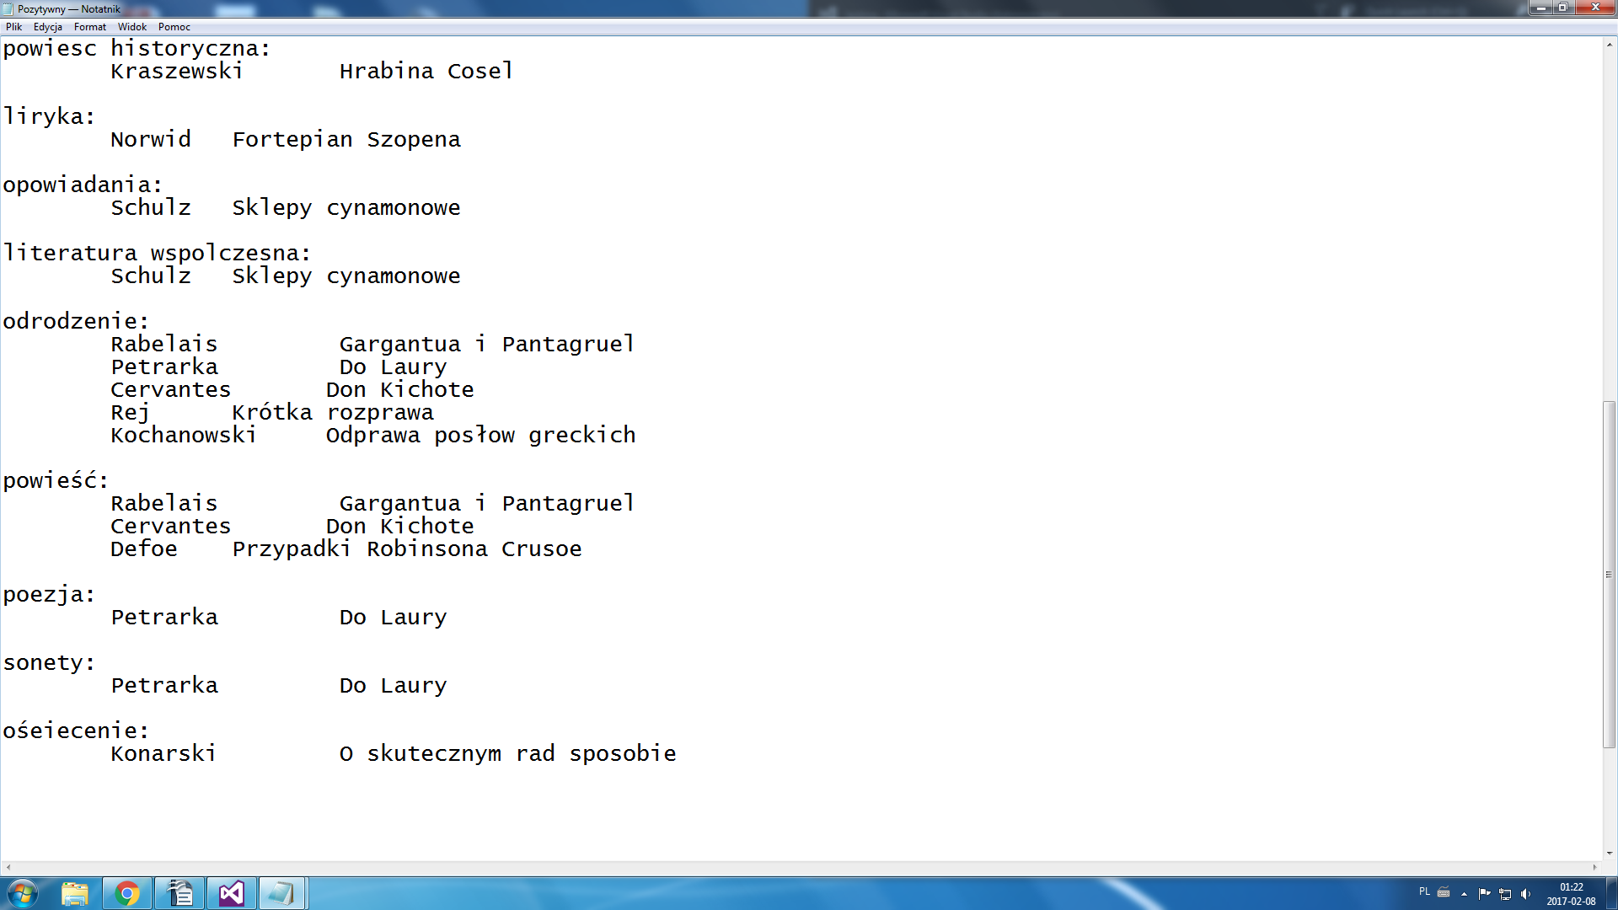

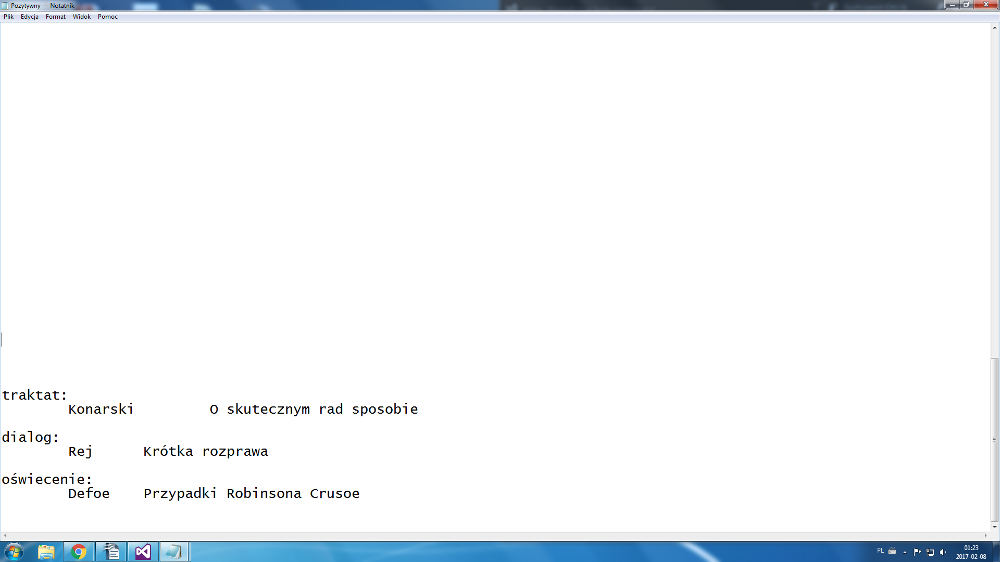
7.Conclusions
This project helped me with understend how the structures works (i hope). That it is possible to treat word not like a letter after letter in some array.

